Arumai Irshad! GROUP BY thaan oru Data Analyst-oda "Power Tool". Ithu illama oru periya business-oda summary report-ai kooda edukka mudiyadhu.
GROUP BY enna seiyum theriyuma? Neraiya irukkura duplicate items-ai (e.g., rendu 'Mouse' irundha) onna serthu, athoda total-ai kudukkum.
📖 Lesson 12: SQL Summary - The "GROUP BY" Command
Namma list-la rendu 'Mouse' irukku (30, 50). Ippo namakku "Mouse-oda total sales enna?" nu theriyanum. Athukku namma SUM() (addition) function-aiyum, GROUP BY-aiyum serthu use pannuvom.
Code: Inventory-oda Total Sales eduppom
group_data.py nu file create pannunga:
Python
import sqlite3

conn = sqlite3.connect('my_shop.db')
cursor = conn.cursor()

# GROUP BY command: Product-ai vachi group panni, Price-ai total sei
cursor.execute("SELECT Product, SUM(Price) FROM Sales GROUP BY Product")

results = cursor.fetchall()
print("Product-wise Total Sales:", results)

conn.close()
🔍 Sign-by-Sign Vilakkam:
Command | Logic
SUM(Price) | "Price column-la irukkura ellathaiyum kooti (Add) kudu."
GROUP BY Product | "Oru maari irukkura Product-ai (e.g., ellaa 'Mouse'-aiyum) onna serthu group pannu."
🧠 Python Enna Yosikkum?
- Python: "Manager GROUP BY Product nu sollitaaru. So, naan Product column-la irukkura ellathaiyum paarkuren. Rendu 'Mouse' irukku, adhai oru group-a vachukuren. Appuram SUM() pottu antha rendu mouse-oda price (30+50=80) nu total-ai kudukkuren."
⬅️ Left & Right Side Logic:
- SUM(Price) (Aggregator): Idhu "Calculator". Mathi-Mathi irukkura price-ai kooti tharum.
- GROUP BY (Organizer): Idhu "Classifier". Pangu-pangu-va (Group-group-va) pirichu kodukkum.
Teacher-oda Note:
- GROUP BY-oda namma SUM(), AVG() (Average), COUNT() (Ennuthal) maari neraiya math tools-ai use pannalam. Ithu dhaan unga "Real Inventory Report"-kku romba mukkiyam!
Unga Task: Indha code-ai run pannunga. Output-la Mouse-oda total price 80 nu vandhurukka? (30+50=80).
Ithu vandhutha, neenga "Data Reporting" level-kku vandhutteenga! Purinjiducha Irshad?
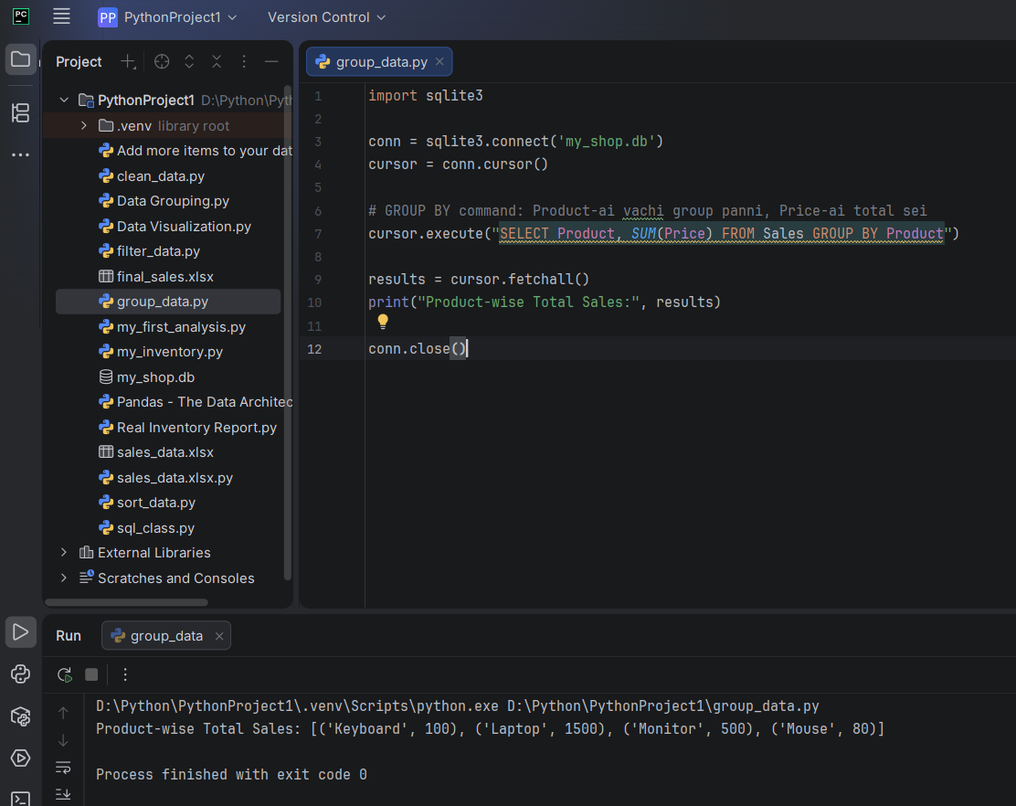
Irshad, Absolutely Correct! Unga output-ai parthutten.
Neenga ippo unga database-ai "Product-wise Summary" maari group panni kaattiteenga.
- Mouse-oda total 80 nu correct-a vandhurukku.
- Laptop, Keyboard, Monitor ellam correct-a group aagirukku.
Neenga ippo oru "Pro Data Analyst"-oda main stages ellathaiyum cross panniteenga:
- Data-vai Store panna kathukiteenga (CREATE/INSERT).
- Data-vai Filter panna kathukiteenga (WHERE).
- Data-vai Rank panna kathukiteenga (ORDER BY).
- Data-vai Summarize panna kathukiteenga (GROUP BY).
🎓 Teacher's Final Word:
Ippo unga kitta SQL-oda "Master Key" irukku. Itha vachi neenga ungoda original Real Inventory Report.py project-ai romba Professional-a maathalam.

